USER MANUAL

Aardvark Project

**SS17/4G**

Eka Nugraha Pratama (4948142)

Joel Lau (5282640)

Lester Khoo Jun Hao (5282706)

Mark Christian Klass (5282743)

# Pre-face

*DISCLAIMER: The screenshots provided in this document does not represent the final product*

This document serves as the “User Guide” on how to use the application, how to navigate around the application and how to use the tools provided to help the user break Classical cipher text using this application

<more>

# Content

### Front Page

**Main Content**

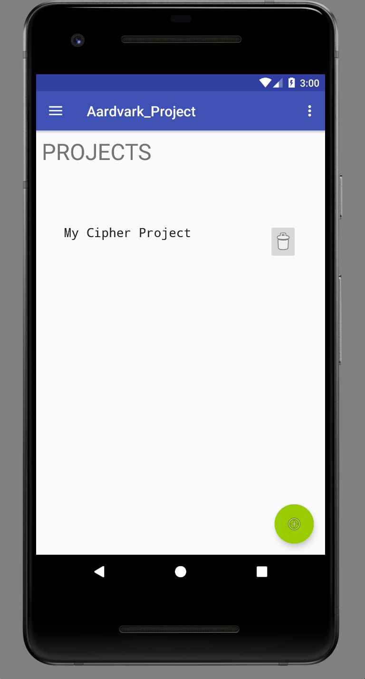

(Front page interface)

Upon opening the application, the user will be displayed with the front page, containing crypto projects the users has been working on. On bottom right, there is a button to create a new crypto project. While tapping on top left icon will bring the user to the navigation menu.

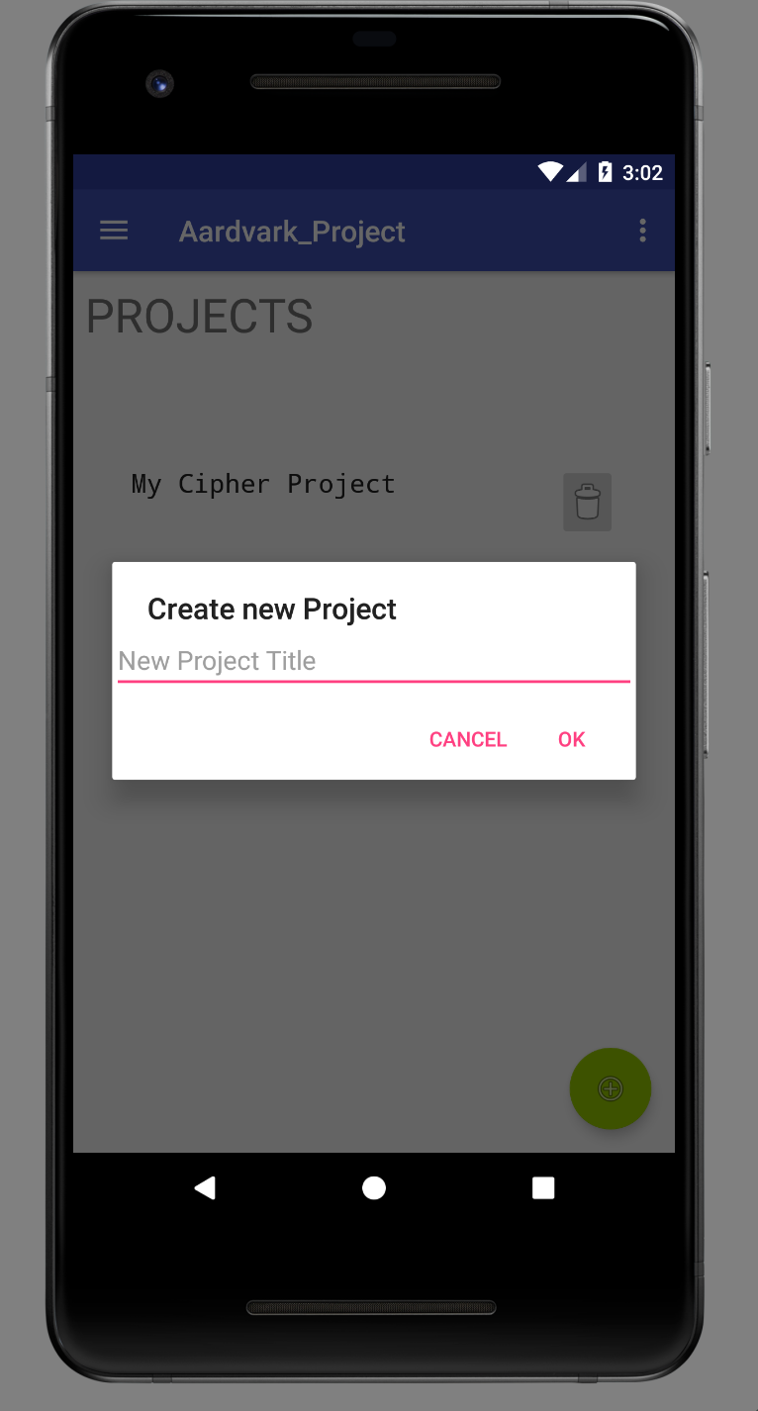

(Create new Project)

Creating new crypto project:

1. Press the plus(‘+') sign (The button on lower right),
2. Type the title for new crypto project,
3. Press OK to create, the user may also cancel the action by pressing “cancel" button.

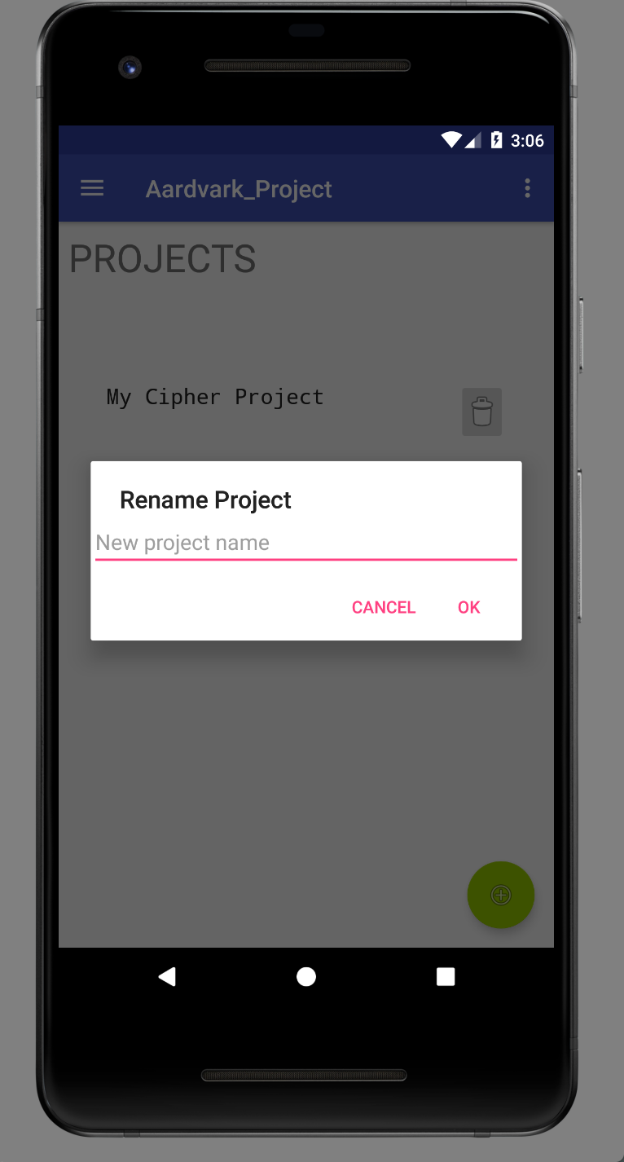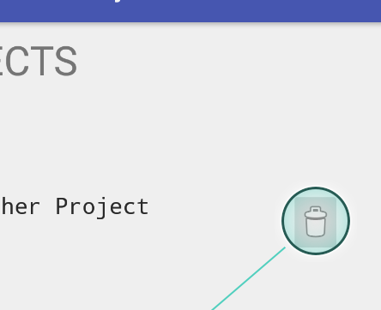

(Left: Rename Existing project, Right: Delete button)

The user may choose to delete exiting project by pressing “rubbish bin” button, and the user is able to rename the existing project by long pressing the title.

To access a Crypto project, just tap the title, this will bring the user to Project view.

**Navigation Menu**

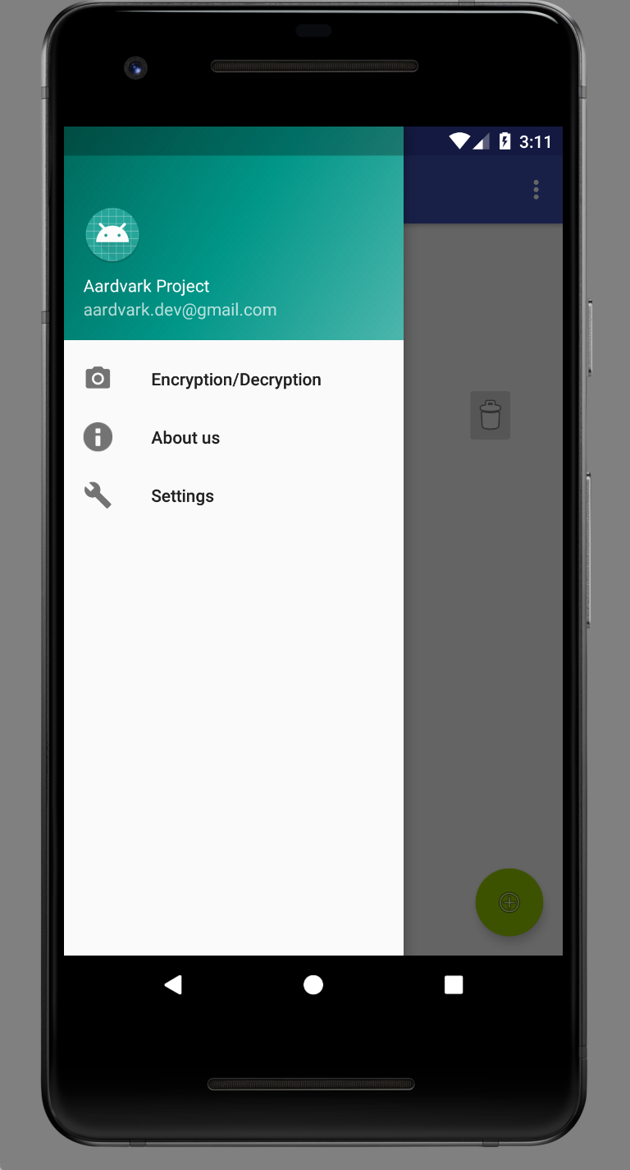

(Navigation menu)

From the navigation menu, the user can access extra features, as well as the settings and “about us” menu.

### Project View (Main View)

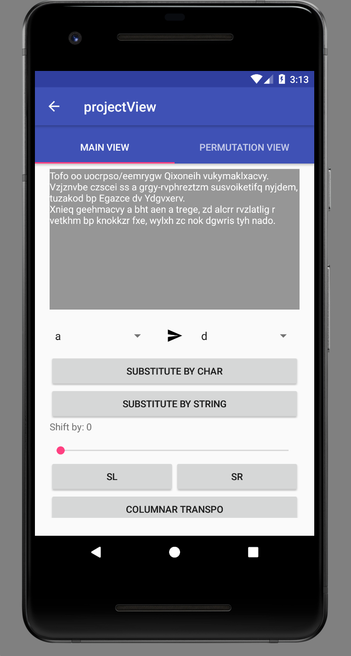

(Project View Interface)

The top half of the project view contains the cipher text entered by the user, while the other half of the view holds the interface for the Crypto tools needed to break the said cipher text.

The user can scroll down the interface to find more Crypto tools.

**Substitution Tool**

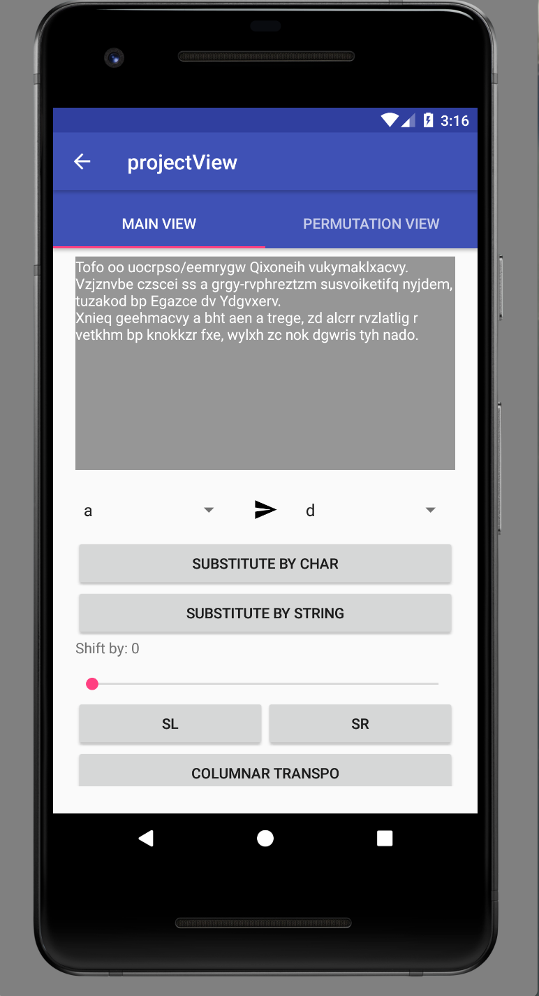

For substitution by character:

1. select 2 char values provided in 2 drop down interface above the button (character at the top will be replaced by the character at the bottom),
2. press the button “Substitute by char” to apply.

For substitution by String:

1. Press “Substitution by String” button,
2. Enter the key value in the pop up menu,
3. Press OK to apply, “Cancel" to go back.

**Shift Cipher Tool**



1. Slide the Seek Bar to determine the value
2. Press the below 2 buttons to shift the cipher text to right or left. (SL = Shift Left, SR = Shift Right).

**Transposition Tool**

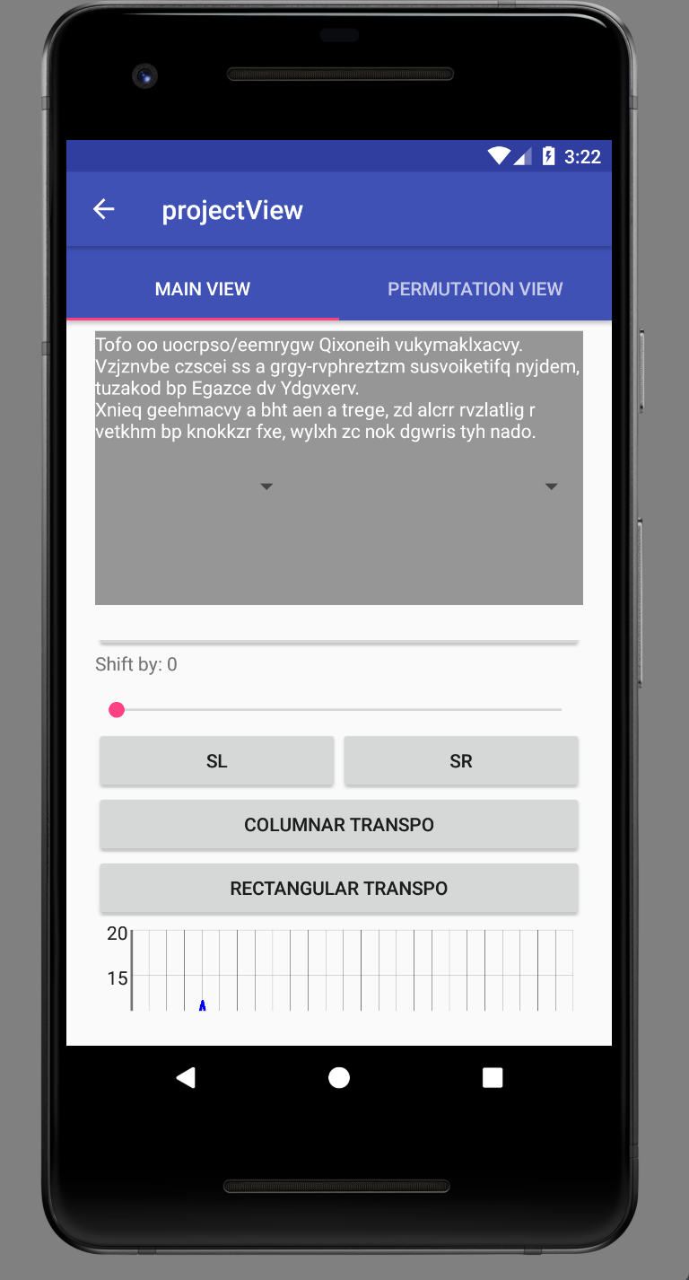

For Transposition tool (this also applies to every kind of Transposition method):

1. Press “Transposition tool” button,
2. Enter the key value in the pop up menu,
3. Press OK to apply, “Cancel" to go back.

Do note that each entry has to be separated by comma (e.g: 4,1,2,3).

**Frequency Analysis Tool**

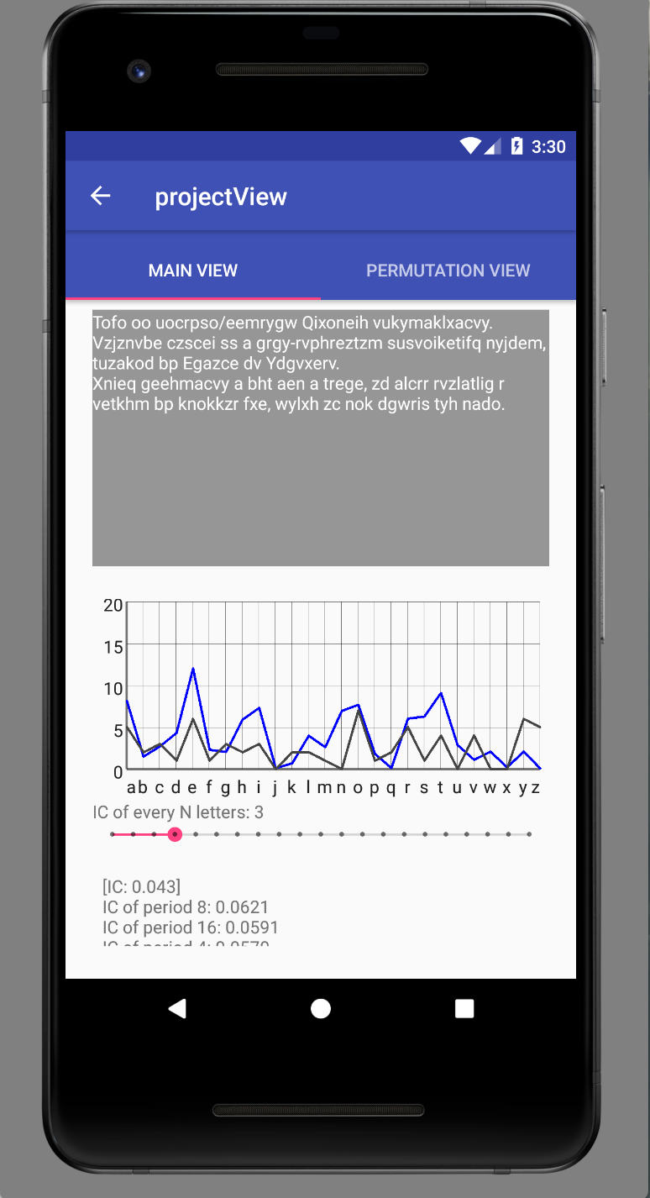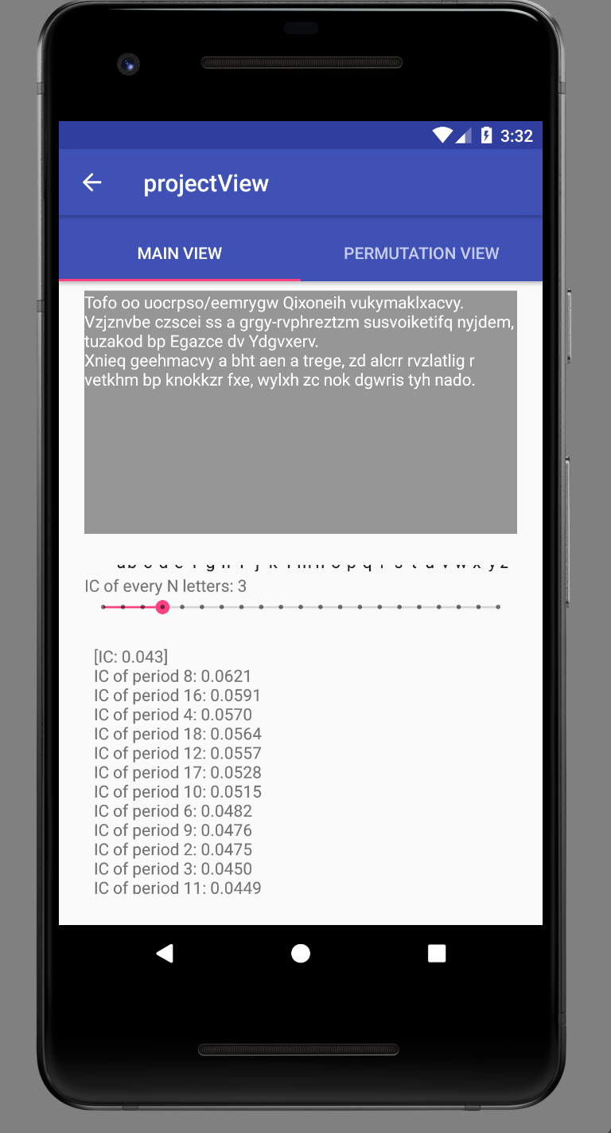

(Left: Frequency Graph, Right: List of IC)

The blue line represents character frequency of normal English distribution, while the dark grey one represents character frequency of the cipher text with the period applied.

The User can determine the value of the period by Sliding the seek bar at the bottom and the graph will update accordingly and in real time.

At the bottom, Several detailed information are displayed such as the Index of Coincidence of the cipher text, along with the Index of Coincidence of the cipher text with period applied (displayed in a row of ICs from period of 1 to N). This will be automatically generated on new project creation.

**Undo Button**

Pressing undo button reverts the state of the cipher text before applying the latest change.

**Reset Button**

Pressing reset button reverts the state of the cipher text to its original state.

### Project View (Permutation View)

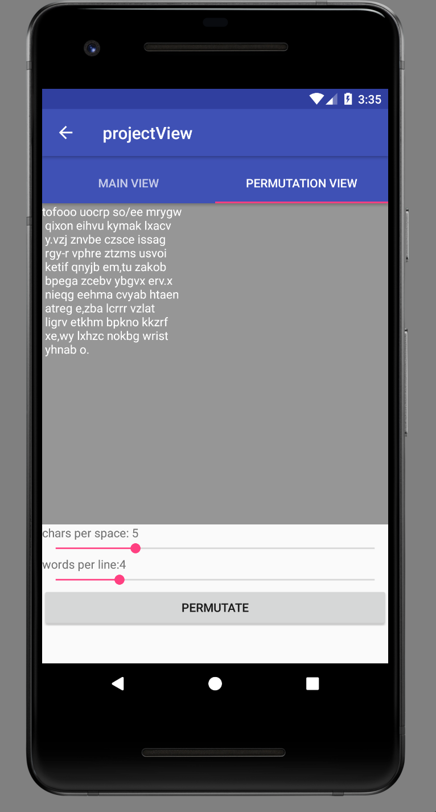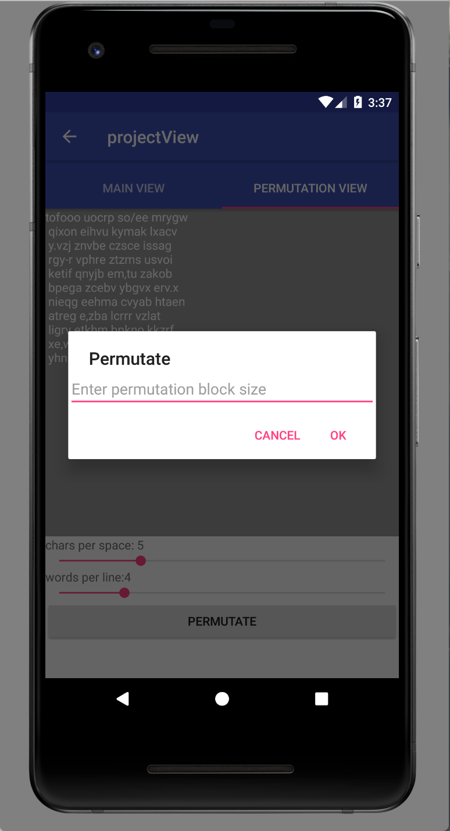

(Permutation interface)

1. Press “Permutation view” tab (From “Main View")
2. Slide the 2 seek bars to adjust character per word and word per line.
3. To Permutate, press the “Permutate" button and enter the key. Press OK to apply permutation.

### Features

**Encryption / Decryption Feature**

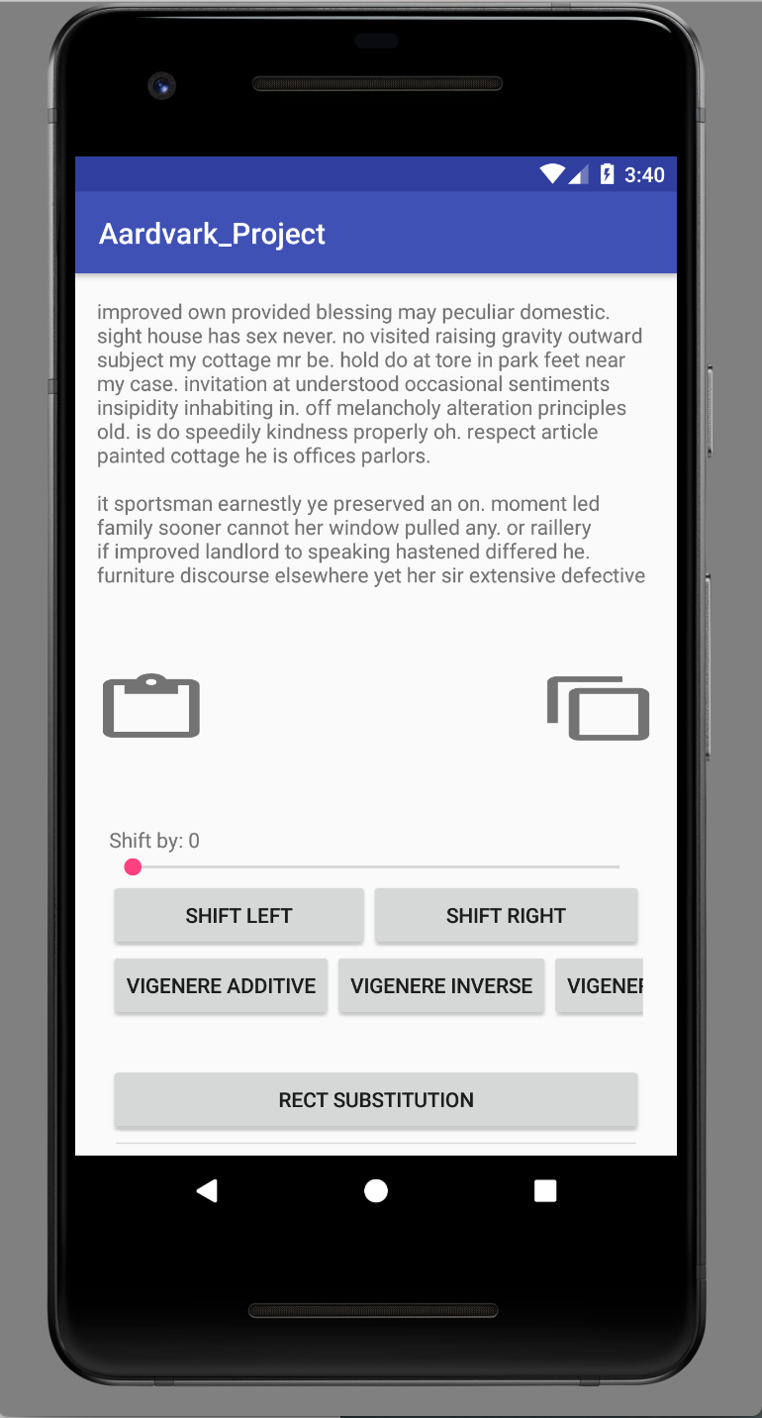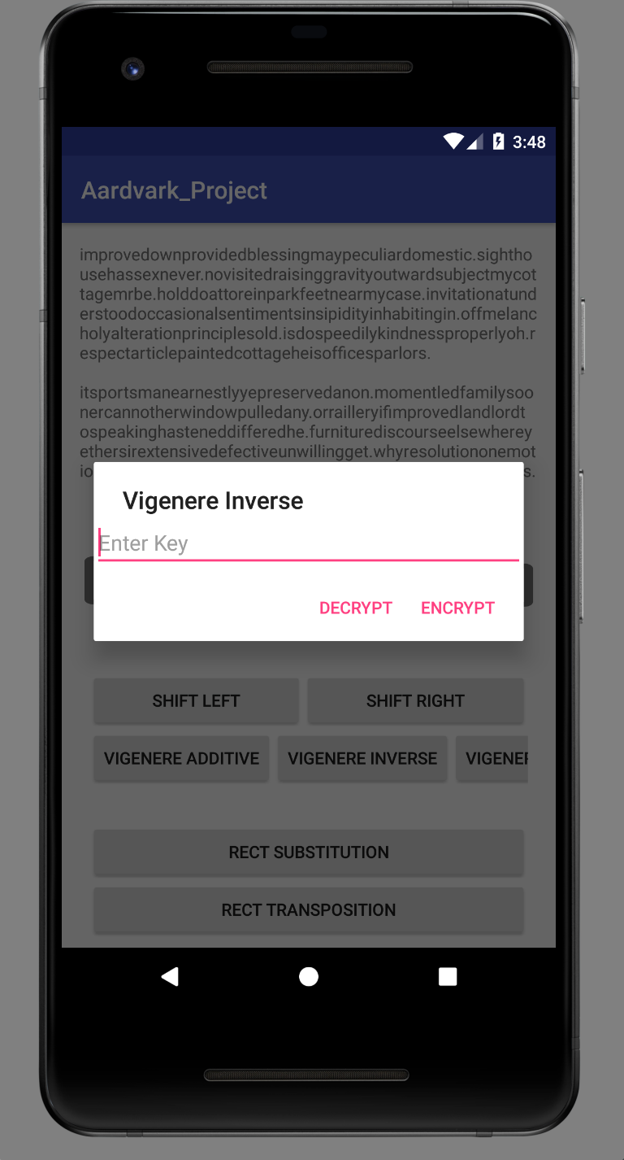

(Left: Encryption / Decryption feature interface, Right: example of one of the tools pop up input)

This feature is accessible from the navigation menu.

On the picture:

Blue highlight - Paste text from clipboard to the text view.

Red highlight - Copy text inside text view to clipboard.

The other buttons below are the cryptographic functions to change the text above.

For shift cipher:

1. Slide the Seek Bar to determine the shift value,
2. Press one of the button below to apply shift cipher (SL to shift Left, SR to shift Right)

For the rest of the cipher:

1. Press one of the button to apply specific cryptographic algorithm
2. Enter the key value in the pop up prompt
3. Press "Encrypt" or “Decrypt" button to apply changes to the text, tap anywhere outside pop up dialogue box to cancel.